**Finding transcripts in Hydra genome**

My goal is to automate the process of having a user input a search term and retrieve a list of transcripts associated with genes that are annotated with that search term. I have shown the steps that someone would take to do this manually. Obviously, this is kind of a pain, especially if there is a long list of results!

1. Go to this website: <http://pfam.xfam.org/search#tabview=tab2>
2. Enter search term in box and click search. Here I’ve used “IG” which returns a large number of results.

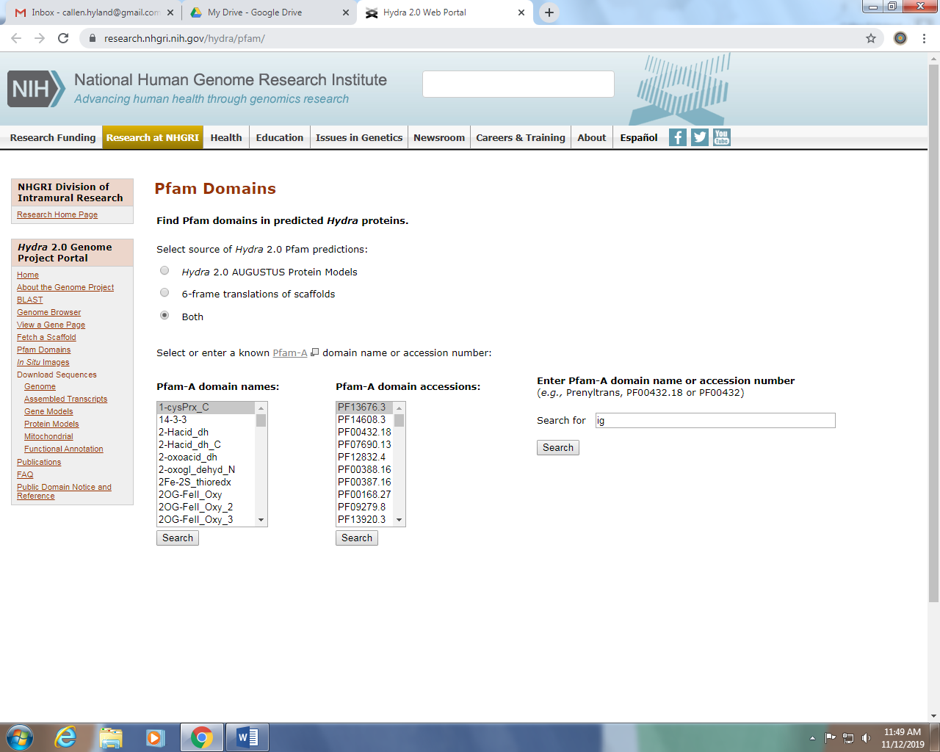

1. Go through each of the search results, clicking on the Gene Identifier, which will take you to another page for that gene.

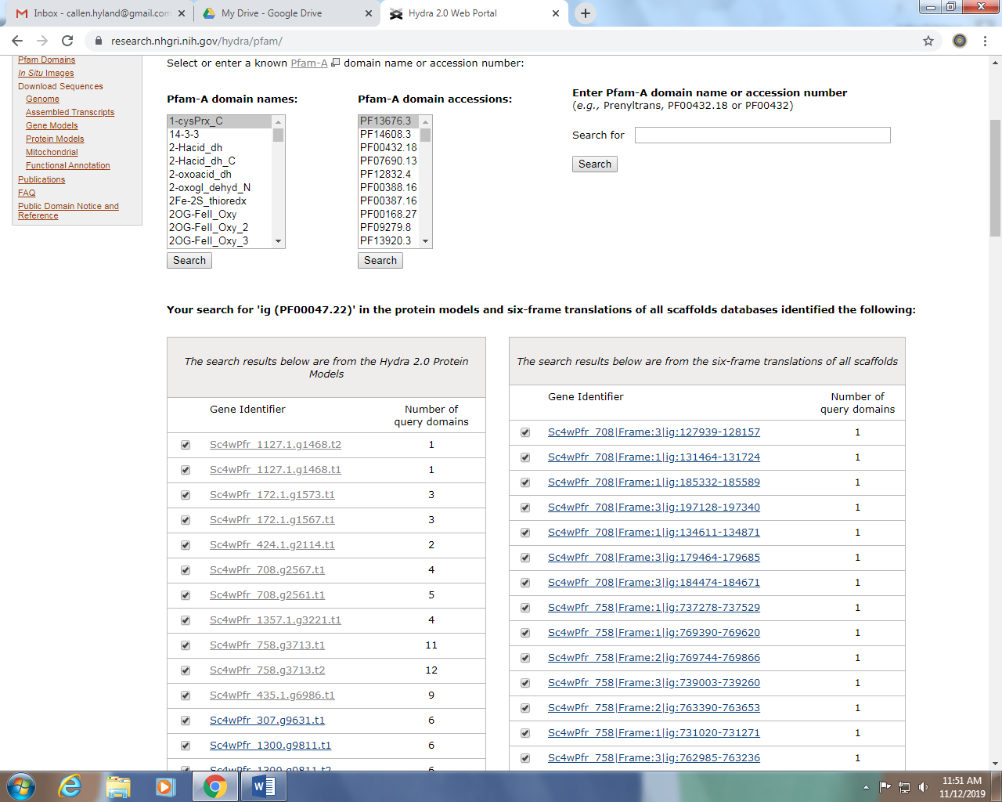

1. For each of the genes you will see a page like this. Click on “view gene in genome browser”.

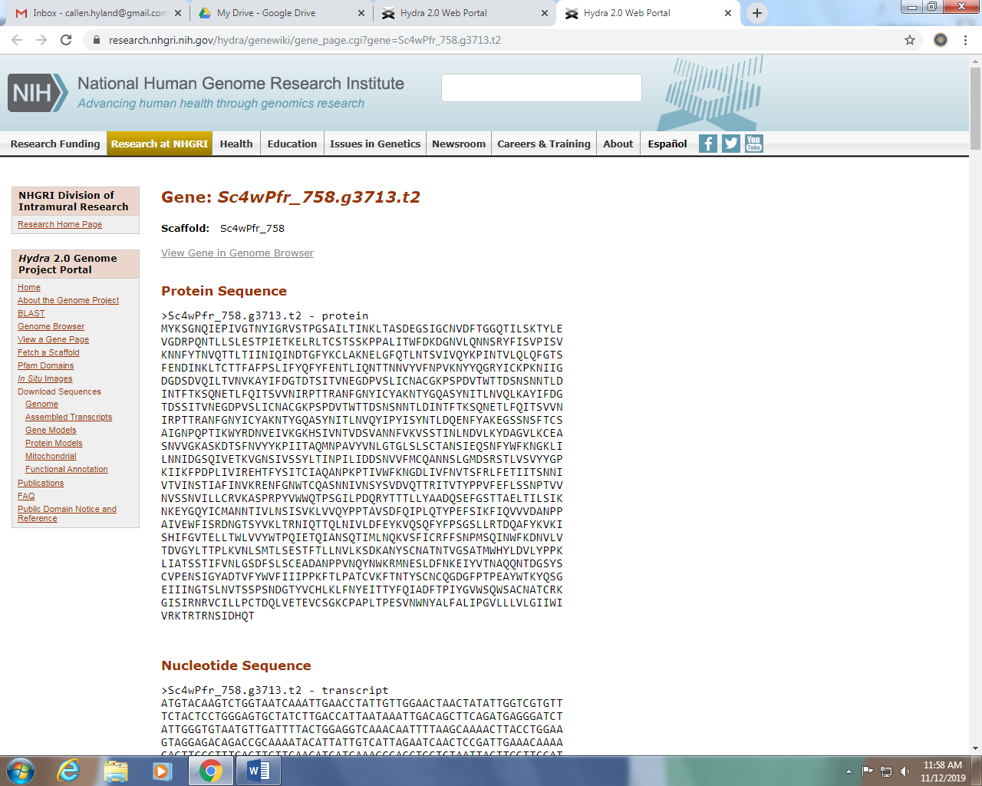

1. You will be sent to a page like this one. From the left panel, check the box next to “Juliano-aepLRv2”. This will bring up an addition transcript track in the genome. The transcript is the black line with green bars. There’s another small black line that probably doesn’t mean anything, but I don’t know a good method of excluding these. There might be one transcript, no transcripts, or many. For now, we probably want to go click on all of them.

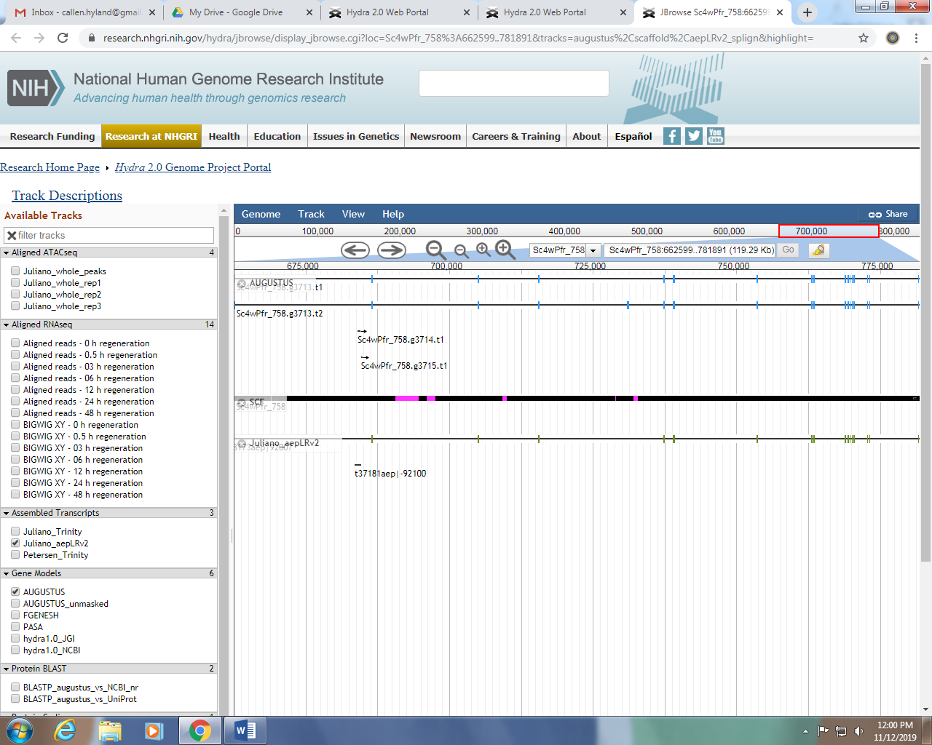

1. Clicking on the black bar will take you to a page like the one below. Next to “symbol” there is a nine character code of the format t#####aep. Add it to the list of transcripts!

